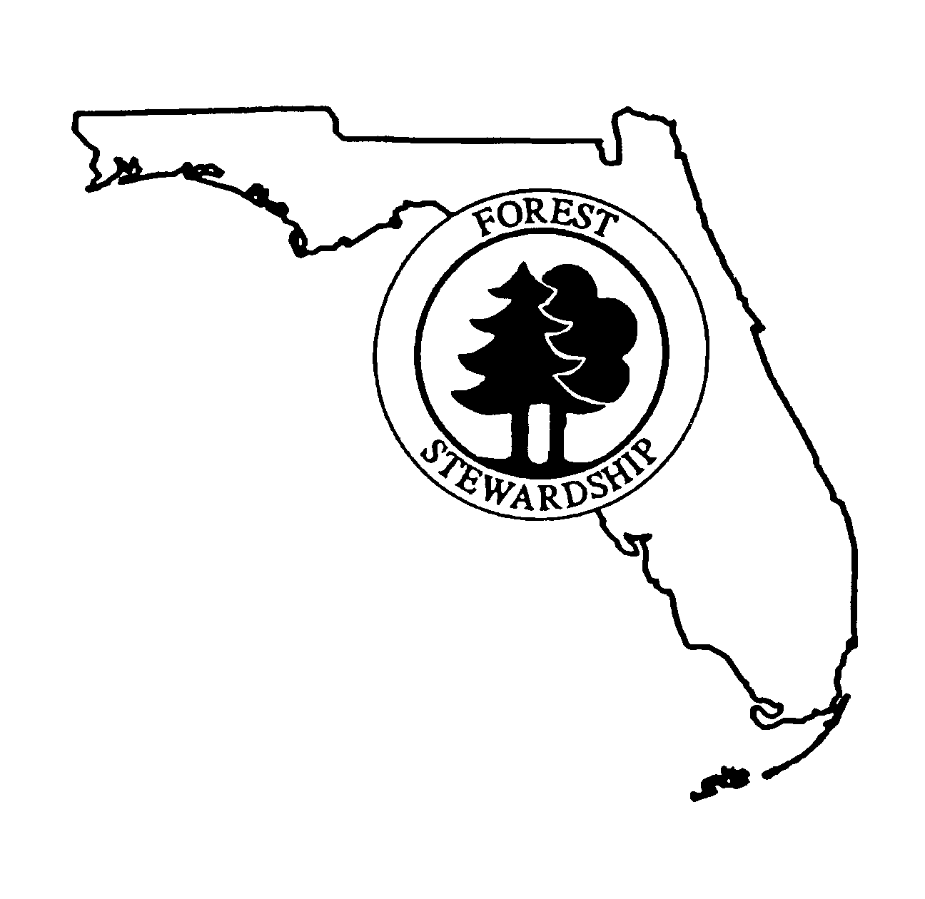
The Florida Forest Steward

A Quarterly Newsletter for Florida Landowners and Resource Professionals

Volume 12, No. 1 Summer 2005

Summary of the Tri-State Longleaf Pine Groundcover Symposium
In this issue:

- Summary of the Tri-State Longleaf Pine Groundcover Symposium
- Sell Your Timber for What It’s Worth
- Funding Available for Planting Longleaf in Northwest Florida
- Timber Price Update
- Upcoming Programs

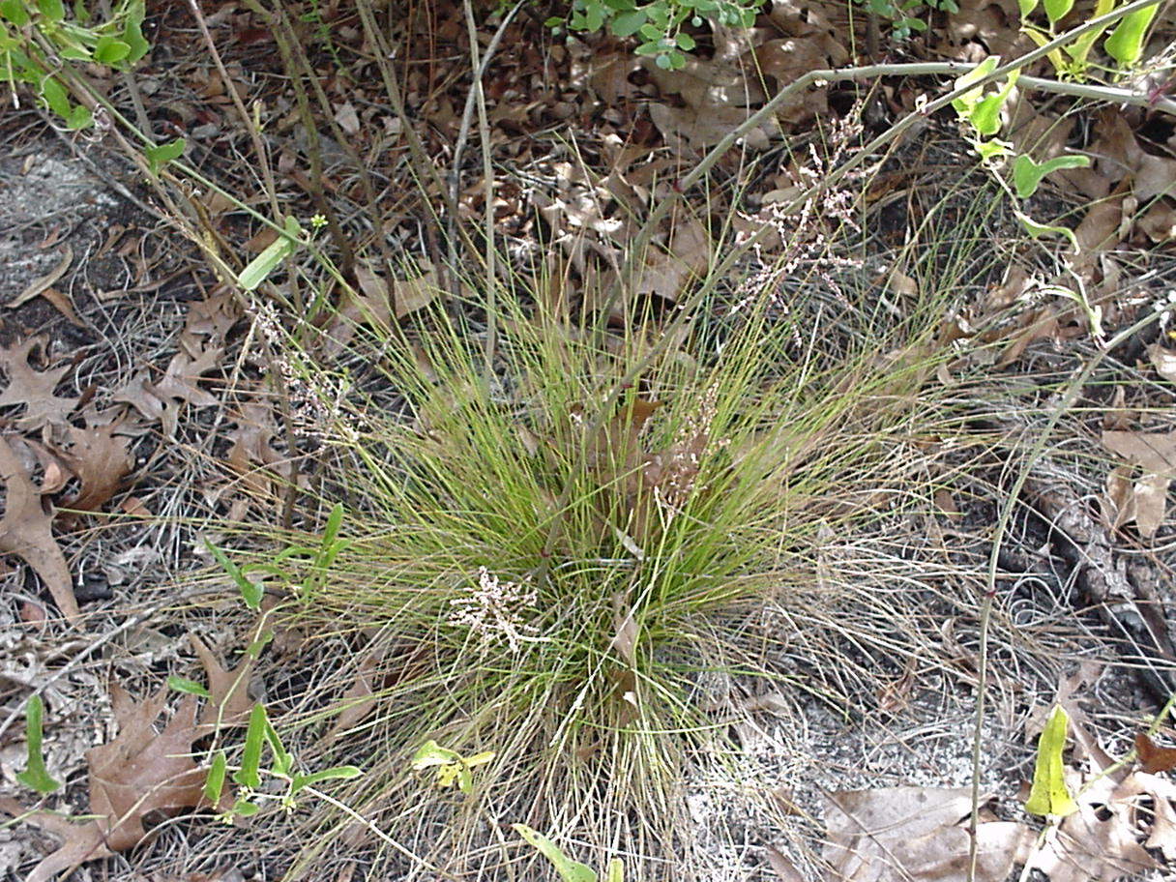
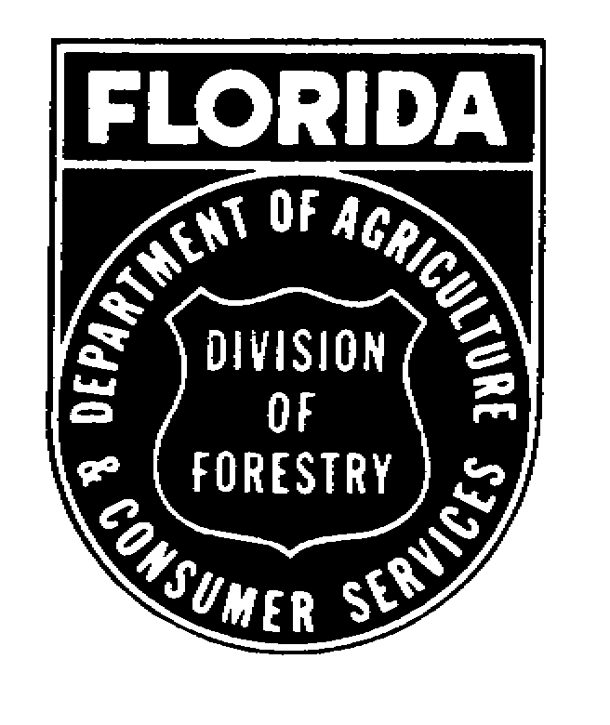
Last November natural resource professionals from Florida, Alabama, and Georgia gathered at the North Florida Research and Education Center in Quincy for a forum on the practical and economic aspects of restoring native ground cover in longleaf pine forests. Several of the topics discussed at this program represent some of the first steps in our efforts to restore groundcover in the longleaf pine ecosystem. With the increased focus over the last decade or so on bringing back longleaf pine to its native range, we now have a useful and growing foundation of knowledge about regenerating and establishing longleaf pine on its native soil. However, there is much yet to learn about bringing back the diverse groundcover of grasses and herbaceous plants that makes up much of the diversity of these systems. This summary will address some of the more useful and practical highlights of this meeting which Stewardship landowners may find helpful in their forest management efforts.

Does it make economic sense to manage a longleaf pine ecosystem?

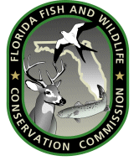

Tall Timbers Research Station did an economic analysis to compare the short- and long-term returns of an even-aged, 40-year rotation loblolly pine stand and an uneven-age longleaf pine stand sustained by single-tree selection harvests. The analysis considered differences in products, management costs, and the value of alternative land uses such as pine straw and hunting leases.

Considering timber values alone, they found that after 40 years the revenue gained from harvesting the loblolly stand were four times greater than that from single-tree harvesting the longleaf pine stand. After 100 years the projected cumulative revenue from the 40-year rotation loblolly stand was only 10% higher than the selection-harvested longleaf stand.

When risk, management costs and some light pine straw harvesting were factored in, cumulative returns for the longleaf stand exceeded that for the loblolly stand after 60 years and maintained a 25% advantage thereafter.

Managing or restoring a longleaf pine ecosystem is costly in the short-term compared to more traditional even-age management of loblolly pine. However, the long-term gains from timber combined with other enterprises may make uneven-age longleaf management attractive for those interested in pursuing it for other non-market benefits like habitat conservation and native species propagation.

Keep it if you have it

Restoration of an ecosystem implies restoration of all components, or as many as possible. One of the biggest challenges with restoring groundcover is that it is still unclear what constitutes intact, native groundcover in fire-maintained longleaf pine forests. We have a pretty good idea about which species of plants grow on the different soil types but there is still much to learn about their relative proportions on a given site. The first step for anyone trying to manage or restore an ecosystem is to keep it if you have it. You may not see wiregrass, gopher apple or asters under your shrubs or oak trees but if you let sunlight hit the soil and reintroduce fire, you may be amazed by the results. Intensive soil treatments like plowing or bedding or unintentionally moving soil through windrowing may alter or remove this seed bank of native plants.

What if I don’t have it?

The most challenging sites on which to restore native groundcover are old agricultural fields, which can be grouped into 3 categories: recently cropped fields, abandoned crop fields and pasture or hay fields. Each presents unique challenges but 2 main obstacles must be overcome in order to restore native groundcover on all 3 sites: (1) the presence of bermudagrass and bahiagrass, and (2) the depletion of desirable species in the soil seed bank by intensive agricultural practices.

Control the exotic grasses before you do anything and use herbicides to do it. Herbicide products such as Arsenal, Plateau, Accord, Roundup and Escort have proven to be most effective in controlling both bahiagrass and bermudagrass in field trials. Follow the label on these products for proper concentrations and supplements.

The objective in using herbicides to control these grasses is to make way for a native, grass dominated fuel base to aid the use of prescribed fire. Regular prescribed fire will prevent establishment of hardwoods and shift plant dominance from old field weeds to more fire-adapted varieties like andropogon, bluestem, ragweed, beggarweed, goldenrod and hopefully more desirable forbs.

Where do I get native groundcover seed?

Seed sources for wiregrass and some other native groundcover plants are, unfortunately, limited for the region. However, the increased interest of public and private landowners and managers to restore native groundcover has led to some important research and operational-scale trials for groundcover plant propagation. One of these is the Native Ground Cover Partners project in Georgia. The Jones Ecological Research Center and the University of Georgia National Agriculturally Sound Production Laboratory are cooperating with private landowners to harvest native groundcover seed on private properties. Cash incentives are provided for landowners to burn high quality ground cover sites during the growing season and for allowing harvesting access. The seed obtained from this effort will be used in demonstration trials and for helping commercial plant growers produce and market native seed.

Native wildflowers are a bit more accessible. The Florida Wildflower Cooperative is an effort of the Florida Department of Transportation and UF-IFAS to produce and market native wildflowers. Their research is focused on facilitating development of commercial sources of native wildflower seeds. An excellent source of assistance with wildflowers is Wildflowers Matter, a free service of the Florida Federation of Garden Clubs. For species and planting recommendations and a list of suppliers, contact Dara Dobson, District 1 Wildflower Chairman, Florida Federation of Garden Clubs, 850-859-0096.

How do I find financial and technical assistance?

Partners for Fish and Wildlife Program: A good source of assistance for landowners interested in restoring longleaf pine groundcover is the U.S. Fish and Wildlife Service’s Partners for Fish and Wildlife Program. The Service has identified the restoration of longleaf pine habitat as high priority for this region of the South and is providing technical and financial support to help landowners restore and enhance native groundcover under longleaf pine. Landowners receiving assistance are required to maintain the restored area for a set period of time while retaining all property rights. For more information about, and state contacts for, the Partners for Fish and Wildlife Program, see the Web site at http://partners.fws.gov/.

Wildlife Habitat Incentives Program (WHIP): WHIP provides funding for wildlife habitat development and maintenance, brush management, prescribed burning, creating wildlife openings and fish stream improvements. Applications are accepted through a continuous sign-up process and can be obtained and filed at any time with your local USDA Service Center. Applications also may be obtained through the Florida Natural Resources Conservation Service website at http://www.fl.nrcs.usda.gov/programs/flwhip.html.

Landowner Incentives Program: The Florida Fish and Wildlife Conservation Commission is cooperating with the U.S. Fish and Wildlife Service to implement a new private landowner assistance program called the Landowner Incentives Program (LIP). Florida’s LIP is a voluntary program designed to provide technical and financial support to those private landowners interested in improving habitat conditions on their properties for species at risk. Native groundcover is often a required habitat component for these species. For an application or more information on the Landowner Incentive Program, visit the Commission’s LIP Web site at http://www.wildflorida.org/lip/ or contact the LIP Coordinator at 850-488-3831.

Many Thanks to the symposium steering committee for a great program:

Dr. Jarek Nowak, UF-IFAS North Florida Research and Education Center
Dr. Shibu Jose, UF-IFAS West Florida Research and Education Center
Mark Hainds, Longleaf Alliance
Ruthie Cole, Florida Division of Forestry
Chuck McKelvy, Florida Fish and Wildlife Conservation Commission
L. Katherine Kirkman, Jones Ecological Center
Stewart Jackson, Tall Timbers Research Station
Jeff Norcini, UF-IFAS North Florida Research and Education Center
Stan Rosenthal, UF-IFAS Leon County Cooperative Extension Service
Will Sheftall, UF-IFAS Leon County Cooperative Extension Service
and many others…

Sell Your Timber for What It’s Worth

Sounds obvious but it doesn’t always happen. Tom Kazee, owner of Woodland Security, Inc. in Orange Park, Florida, had a great article about this subject in the March/April issue of Tree Farmer magazine (Volume 24, Number 2). It hits some extremely important points for anyone who sells or is planning to sell timber. The take home message of the article is this: to recover all the payment due to you for your timber, you and/or your forester must know what the product specifications are and ensure the timber is sorted properly. If you sell your sawtimber for a pulpwood price you will lose a lot of money. Among Tom’s many helpful ideas were these three really important concerns.

Be familiar with the market and mills in your area

Keep in mind that the buyer is under no obligation to inform you of the various product classes and their value, i.e., how much your trees are really worth. I was visiting with a landowner and consultant in Walton County last spring and learned some new forest product vocabulary: “superpulpwood”, “canterwood” and “micrologs”. These are some relatively new product classes that are essentially different names for a similar size class – somewhere between pulpwood and chip-n-saw. Some areas have mills that buy these products and some don’t. If you and/or your forester are aware of them, they can increase the value of your sale significantly.

Have practical expectations

In many cases, loggers have incentives to maximize production – bigger loads faster. If there aren’t enough stems of a particular product class to make a load, then trees of that class will end up going where the rest of the load is going. For example, if your sale is a first thinning in a young plantation you can probably expect all of it to sell as pulpwood, even though there are 9 or 10 stems that are technically in the chip-n-saw class.

Plan and execute your sale carefully…….and get help

Marketing your timber is usually the culmination of a long investment strategy and a means to reach a variety of resource management objectives. It deserves patient planning, careful consultation and a keen knowledge of what and why you are selling. If you are not experienced in or comfortable with selling timber, get help. A consulting forester can perform all duties of the sale, including an inventory and the sale contract itself for a fee. It will pay off to get it done right.

Funding Available for Planting Longleaf Pine in Northwest Florida - Southern Company’s Longleaf Legacy Program
The Longleaf Legacy Program is a partnership between the Southern Company and its five operating company affiliates (Alabama Power, Georgia Power, Gulf Power, Mississippi Power, and Savannah Electric and Power) and the National Fish and Wildlife Foundation. The purpose of this partnership is to provide grants for longleaf pine reforestation and conservation within the Southern Company service area of Georgia, Alabama, northwestern Florida, and southeastern Mississippi. The Program is planned as a five-year partnership (2004-2008). The goals of the Longleaf Legacy Program are 1) reforestation of longleaf pine forests and restoration of these ecosystems, and 2) sequestration of atmospheric carbon dioxide.
Funding Available
A total of $1,000,000 in grant funds is available annually. Individual grants will not exceed $250,000. Awards may be a combination of Southern Company and other private or federal Foundation funds (typically, awards from The Longleaf Legacy Program will be 50% private funds from Southern Company and 50% federal funds from the Foundation).
Grant awards to date have ranged from $75,000 - $250,000. Competition for funds is stiff. In 2003, 16 preproposals were submitted, and of these, 9 were selected for possible funding. Five were ultimately funded.
Project Area
Georgia, Alabama, Florida Panhandle (west of the Apalachicola River), and southeast Mississippi.
Focus
The focus of the Longleaf Legacy Program is habitat restoration and biodiversity improvement and sequestration of atmospheric carbon. Southern Company plans to register or report the carbon sequestration from these projects through the DOE 1605(b) Voluntary Reporting Guidelines as part of its Power PartnersSM commitments. Southern Company may also report the carbon sequestration from these projects as part of any other greenhouse gas reporting as it deems appropriate. Southern Company and its affiliates may use the carbon credits generated from the Longleaf Legacy Program for compliance purposes with future greenhouse gas requirements, but has no plans to liquidate trade or sell any of the carbon credits that might accrue as part of their grants. Likewise, recipients will not have the right to liquidate, trade or sell any of the carbon credits that might accrue to projects that are funded by this program for a term of 100 years.
Requests for land acquisition to facilitate reforestation are acceptable, but reforestation of secured properties is preferred. Projects that enhance reforestation of existing or planned longleaf ecosystems are given priority. Conversion of loblolly or other stands to longleaf will be considered.
Match
All grant awards require a minimum 1:1 match of cash or contributed goods and services. Higher ratios of matching funds will help make proposals more competitive.
How to Apply
Only electronic preproposals submitted through the on-line preproposal form, at https://collective.nfwf.org/pre-proposal/Preproposal.php, will be considered. Just above the map on this Web site, about midway through the application, select “I am interested in a specific program.” Scroll down to Southern Co. Longleaf Pine, and select this option.
Following a review period of about six weeks, preproposals will be selected and applicants invited to submit full proposals. The 2005 preproposal deadlines are January 7 and May 13. Deadlines for full proposals: February 18 and June 24, respectively. Following a review of about five months, final decisions will be made. If you have a planting project you would like funded but can’t make these deadlines, have your ideas ready for next year’s round.
Contact
Applicants are urged to contact Peter Stangel (404-679-7099) at the National Fish and Wildlife Foundation to discuss project ideas prior to submitting proposals.
Timber Price Update

This information is useful for observing trends over time, but does not necessarily reflect current conditions at a particular location. Landowners considering a timber sale would be wise to let a consulting forester help them obtain the best current prices. Note that price per ton for each product is included in parentheses after the price per cord.

Stumpage price ranges reported across Florida in the 1st Quarter 2005 Timber Mart-South (TMS) report were:

- Pine pulpwood: $14-$27/cord ($5 -$10/ton), ↑ from 4th Quarter 2004
- Pine C-N-S: $53 - $76/cord ($20 - $28/ton), ↓
- Pine sawtimber: $84 - $114/cord ($31 - $43/ton), ↓
- Pine plylogs: $105 - $127/cord ($39 - $47/ton), ↑
- Hardwood pulpwood: $11 - $25/cord ($4 - $9/ton), ↑

A more complete summary of 1st Quarter 2005 stumpage prices is available at your County Extension office. See forest2market.com for weekly, South-wide, per-ton price updates for the major pine and hardwood timber products.
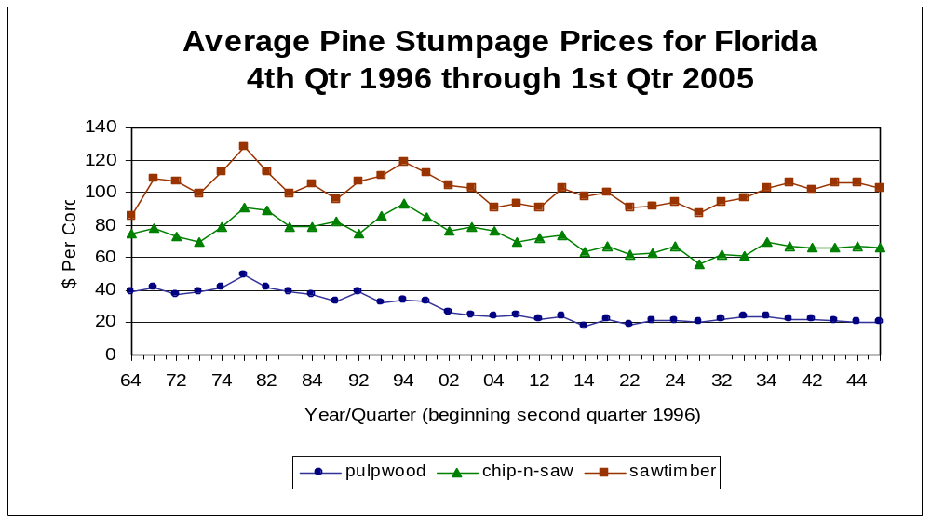
Trend Report

The graph above charts average quarterly stumpage prices, reported in Timber Mart-South for three major log classes for all of north Florida. Numbers on the horizontal axis indicate the year (first digit) and quarter (second digit), so 64 indicates the fourth quarter of 1996.

South-wide average pine timber prices were on the increase in the first quarter for all the major products. With the exception of an increase in average pulpwood stumpage prices, this was not the case for Florida, which may be attributed to high supplies from continuing salvage operations from the hurricanes. The good news is pine pulpwood prices are on the rise across the south. The average pulpwood price for the 11 state region increased 16% in the first quarter, and some reports from the western parts of the region were up more than a dollar per ton.

Upcoming Events

Suwannee Valley Twilight Field Day; May 24, 2005, 4-7 PM, Suwannee Valley Research and Education Center in Live Oak. Topics will include hydroponics, fruit and nut crops, agronomic crops, vegetable crops, and forestry research. Registration fee is $10 and includes meal, tour book, refreshments and other materials. Call the SVREC at 386-362-1725 for more information.
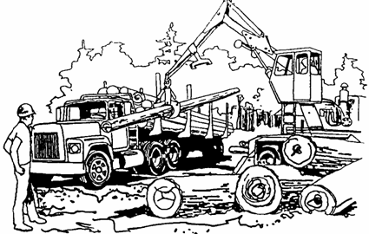
Managing Wildlife on Private Lands;
June 6, 2005, 1-4 PM, Osceola County
Extension Office, Kissimmee FL. Call
321-697-3000 to register.

Forest Stewardship Workshop Series:
Estate Planning and Timber Taxes.
Steven J. Small, a tax attorney and
author of “Preserving Family Lands”
summarized this issue pretty well:
“Millions of acres of family land all
across the country may be lost because
most landowners don’t know about the
tax problem they face. Do you?” This
workshop series will provide an
overview of issues relating to estate
planning and timber taxation, with the
intent of making landowners aware of
their options and obligations, so they can
communicate effectively with planning
advisors or accountants. Presenters include Dr. Josephine Turner, UF-
IFAS Family, Youth and Community
Sciences; Drew Melville, Conservation
Trust for Florida; and Larry Bishop,
USDA Forest Service. Announcements
with more details have been mailed.
Questions about the program can be
directed to Chris Demers at 352-846-
2375. Mark your calendars:

June 20, 2005, 9 AM – 2:15 PM; Estate Planning and Timber Taxes. UF-IFAS Washington County Cooperative Extension Office in Chipley, FL. Call the County Extension Office at 850-638-6180 to register. $7 at the door.

For more information about Florida’s Forest Stewardship Program and forest management visit the Florida Forestry Information Web site at www.sfrc.ufl.edu/Extension/ffws/ffwshome.htm
June 30, 2005, 9 AM – 2:15 PM; Estate Planning and Timber Taxes. UF-IFAS Clay County Cooperative Extension Office in Green Cove Springs, FL. Call the County Extension Office at 904-284-6355 to register. $7 at door.
A University of Florida Cooperative Extension Service and Florida Division of Forestry joint project:

Chris Demers (editor), School of Forest Resources & Conservation, UF, P.O. Box 110410, Gainesville, FL 32611-0410, (352) 846-2375 or cdemers@.ifas.ufl.edu
Alan Long (co-editor), School of Forest Resources & Conservation, UF, (352) 846-0891 or AJLong@ifas.ufl.edu
Ruthie Cole (co-editor), Florida Division of Forestry, 3125 Conner Blvd, Tallahassee, FL 32699-1650, (850) 414-9912 or coler@doacs.state.fl.us
Chuck McKelvy (co-editor), Florida Fish and Wildlife Conservation Commission, 3125 Conner Blvd, Tallahassee, FL 32699-1650, (850) 414-9911or Chuck.McKelvy@MyFWC.com

July 14, 2005, 1 – 8 PM: Cover Your Assets II – Cover Your Assets Too. UF-IFAS Osceola County Cooperative Extension Office in Kissimmee, FL. This program will be targeted for landowners in the fastest-growing parts of the state. In addition to estate planning, we’ll be looking at other income or cost-saving opportunities and some new strategies that are being used to plan development in rural areas. Call the Osceola County Extension Office at 321-697-3000 to register.

WFREC Wildlife Expo and Forestry Field Day, September 29, 2005 at West Florida Research and Education Center in Jay, Florida. Call Robin Vickers at 850-983-5216 x.113 to register.

