Make a Frog Sound
Kit Instructions
Gather the following items:
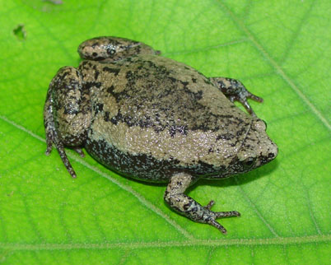
- 1 Zip-Lock Bag
- 2 Glass Beads
- 1 Comb
- 1 Rubber Band
- 1 Balloon

FROGS/TOAD SOUNDS
Cricket Frog: Glass Beads
Click the beads together 3 or 4 times in a row
Chorus Frog: Comb
Strum the comb
Bronze Frog: Rubber Band
Stretch rubber band between fingers/thumb & pointer finger then pluck with fingers from other hand
Leopard Frog: Balloon
Blow up balloon, hold in one hand and rub/stroke the balloon with the other hand making a sound
Narrow Mouth Toad
Hold Nose & Say “Beeee” For 3 Seconds

